**Title:** Lab 11. Frequency Response of Amplifier

**Name:** Robert Bara

**General Objective:** The purpose of lab 11 is to evaluate the frequency response of both a common source and common emitter amplifier by simulating results within Multism.

**Background Activities:** The frequency response of an electric circuit is a way to measure how the output gain and phase change with respect to frequency. The frequency response is typically graphed using a Bode Plot where frequency is the x-axis in hertz while the vertical y-axis is typically represented in terms of gain measured in decibels using a logarithmic scale. A decibel is 1/10th of a bel (B), calculated as ${20*log}_{10}(A)$, with A being the decimal gain. 0dB occurs approximately when the output is equal to the input, therefore yielding a gain of 1 or ${20*log}_{10}(1)$ =0dB. The bandwidth of an amplifier may be represented by the following equation, $Bandwidth \left(BW\right)=f_{H}-f_{L}$. When the output drops from 0dB to -3dB at a fixed rate, this is known as the roll-off region of a response curve. In single order amplifiers and filters, the roll-off rate is typically 20dB/decade or 6dB/octave which are multiplied by the order of the circuit.

**Procedure**

Two circuits will be built, a Common Source using a BS170 NMOS and a Common Emitter using a 2N3904 NPN as follows,

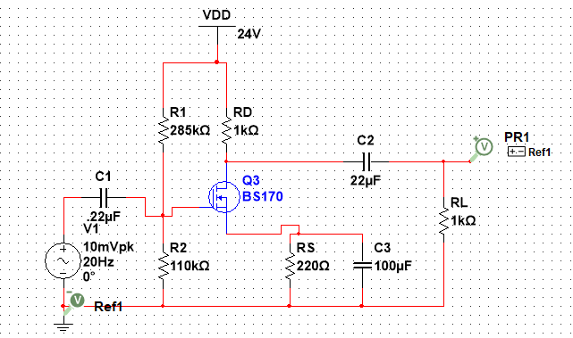

Figure 1. Common Source Amplifier

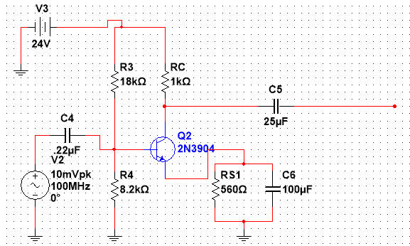

Figure 2. Common Emitter Amplifier

For both amplifiers, create a table that measures frequency (Hz) from 20Hz to 100M, Vout, Av (Gain)=Vout/Vin, and the gain in decibels. Upon creating the table, plot the Bode plot for the frequency response. Compare the analytical Bode plot to a simulation using Multisim’s AC Sweep with a start frequency of 1, stop frequency of 10, and 10 points per decade.

**Results:**

* 1. **Simulation Results**

MOSFET

By running a transient response, I found Vout using multisim’s transient response and taking the ymax of each peak, from that I calculated gain as ymax/10mV from the input source, then converted it into decibels.

|  |  |  |  |
| --- | --- | --- | --- |
| Freq (Hz) | Vout | Av(Gain)=Vout/Vin | 20*log(Av)(dB) |
| 20 | 1.23E-02 | 1.23E+00 | 1.80E+00 |
| 50 | 1.47E-02 | 1.47E+00 | 3.32E+00 |
| 100 | 1.43E-02 | 1.43E+00 | 3.09E+00 |
| 200 | 1.44E-02 | 1.44E+00 | 3.15E+00 |
| 1.00E+03 | 1.44E-02 | 1.44E+00 | 3.16E+00 |
| 5.00E+05 | 1.37E-02 | 1.37E+00 | 2.72E+00 |
| 1.00E+06 | 1.35E-02 | 1.35E+00 | 2.63E+00 |
| 1.00E+07 | 1.32E-02 | 1.32E+00 | 2.43E+00 |
| 2.00E+07 | 1.21E-02 | 1.21E+00 | 1.63E+00 |
| 5.00E+07 | 8.32E-03 | 8.32E-01 | -1.60E+00 |
| 1.00E+08 | 4.48E-03 | 4.48E-01 | -6.98E+00 |

Running an Multisim’s AC sweep to compare,

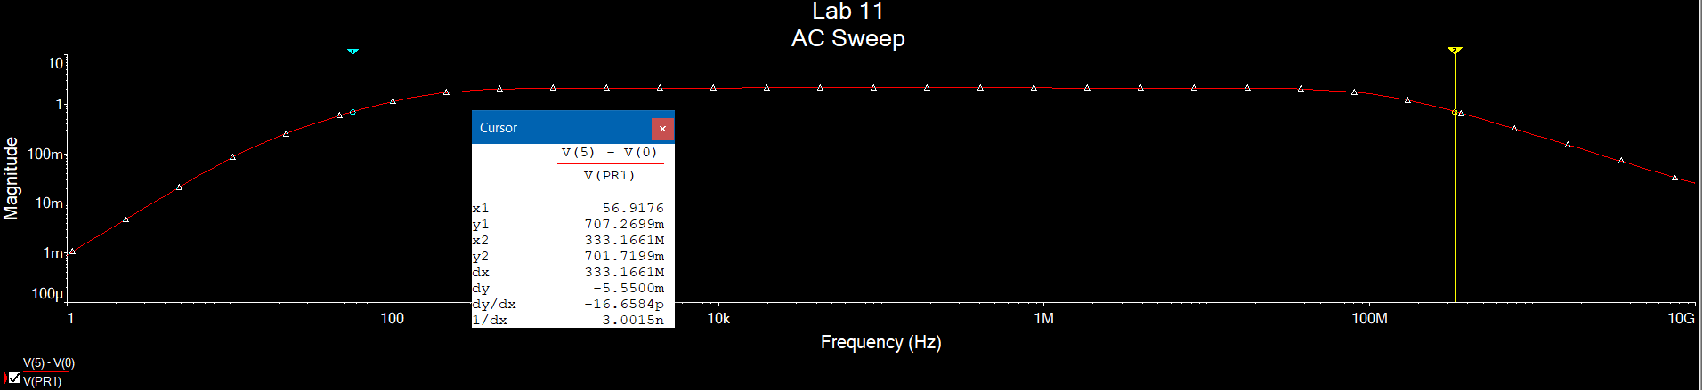

Figure . AC sweep of MOSFET circuit

BJT

I did the same procedure I did for the MOSFET but this time using the BJT circuit.

|  |  |  |  |
| --- | --- | --- | --- |
| Freq (Hz) | Vout | Av(Gain)=Vout/Vin | 20*log(Av)(dB) |
| 100 | 0.355682 | 35.56817 | 31.02123042 |
| 200 | 0.714883 | 71.4883 | 37.08469939 |
| 500 | 1.59E+00 | 159.16 | 44.03667861 |
| 1.00E+03 | 2.3787 | 237.87 | 47.52679345 |
| 2.00E+03 | 2.8592 | 285.92 | 49.1248907 |
| 1.00E+04 | 3.0916 | 309.16 | 49.80366597 |
| 5.00E+04 | 3.101 | 310.1 | 49.83003532 |
| 1.00E+05 | 3.1032 | 310.32 | 49.83619533 |
| 1.00E+06 | 3.1198 | 311.98 | 49.88253507 |
| 1.00E+07 | 2.6826 | 268.26 | 48.57111841 |
| 2.00E+07 | 2.1669 | 216.69 | 46.71677739 |
| 5.00E+07 | 1.1093 | 110.93 | 40.90098026 |
| 1.00E+08 | 5.70E-01 | 56.97754 | 35.11407389 |

Plotting gain in dB against frequency yields,

Comparing this to Multisim’s AC Sweep,

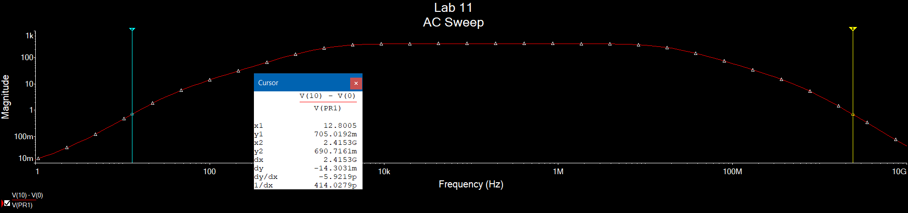

Figure . AC Sweep of BJT Circuit

1. **Conclusion:**

This lab explored the frequency response of an amplifier by finding the bode plot analytically and through simulation of a MOSFET and BJT amplifier. Comparing graphs between the MOSFET and BJT, the BJT has a smaller bandwidth with a larger time it takes to roll off. The MOSFET has a larger bandwidth and rolls off around 100Hz and 100MHz while the BJT starts to level off around 2kHz and 10MHz. By changing the capacitors, we are changing the filter of the input signal going into the transistor, as well as the amplified output, therefore the cutoff frequencies and time it takes (since the time constant T=RC) will be modified based on the mathematical relationship that $f=\frac{1}{2πRC}$, where increasing capacitance will increase the frequency while increasing resistance will decrease the frequency.